**OS LAB 1**

Name: Khadija Shafique

RollNo: BSEF17A533

Basic Shell Commands

Q1) whoami is used to see the user name.

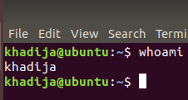

Q2) touch testingFile is used to create file in temp.

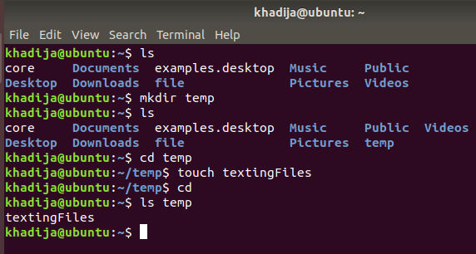

Q3) file testingFile is used to check type of testingFile.

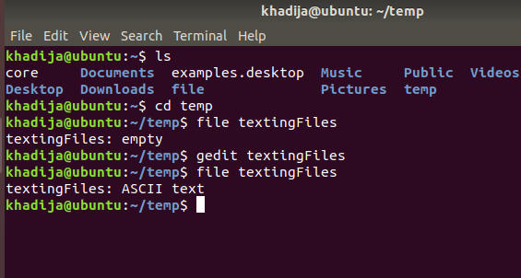

Q4) rm command is used to remove directory that is even not empty, but rmdir command is used to remove only empty directory.

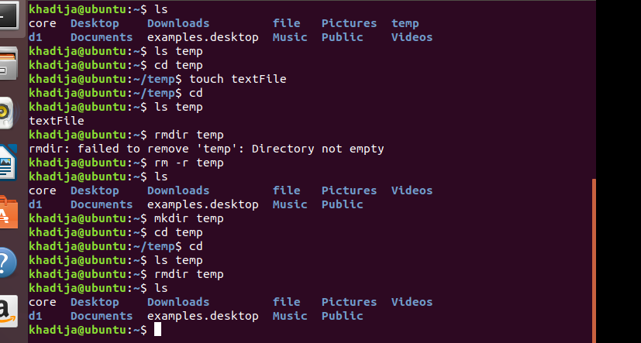

Q5)cd../ is used to move towards home directory.

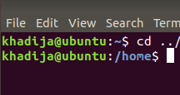

Q6) cv command is used to rename the file v command is used to rename the file. 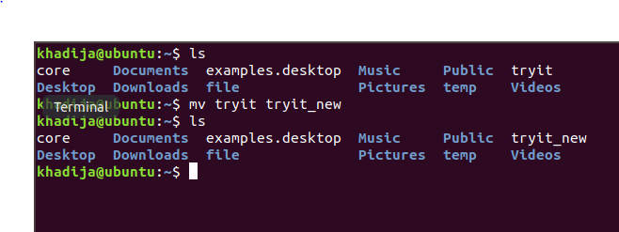.

Q7) alias myclear=”clear” is used to give another name.

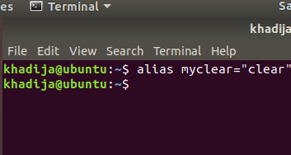

Q8) output#1:-

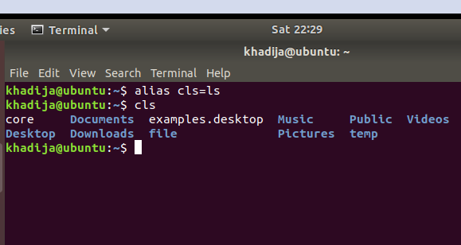

Output#2:-

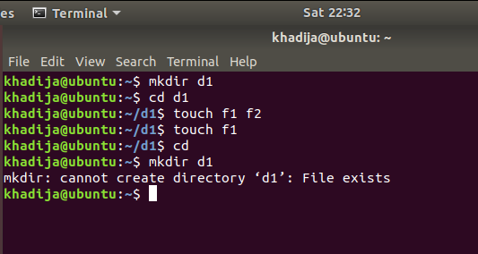

**QUESTIONS**

Q1) mkdir –p temp/BSEF17A533/Khadija/OS is single line command.

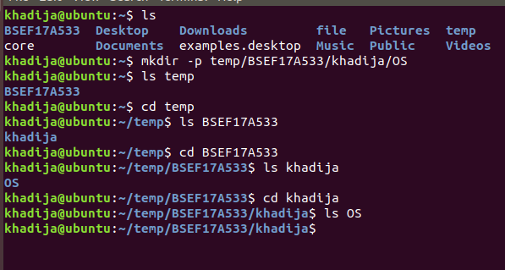

Q2) ls –al command is used.

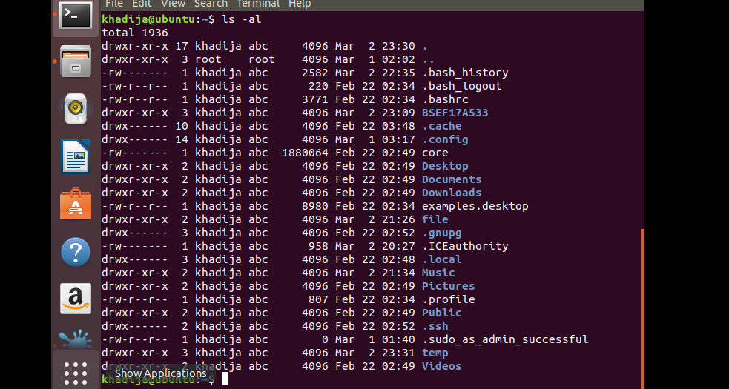

Q3)remove three subdirectories

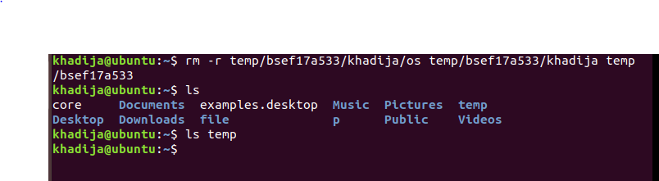

Q4)

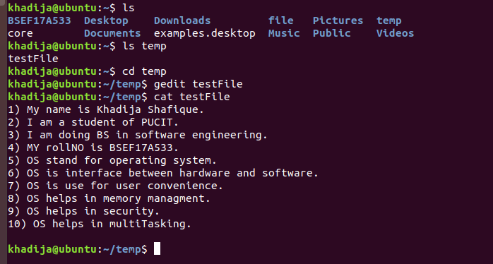

Q5)

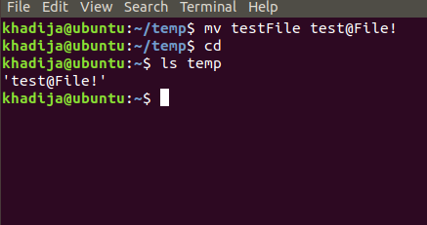

Q6)

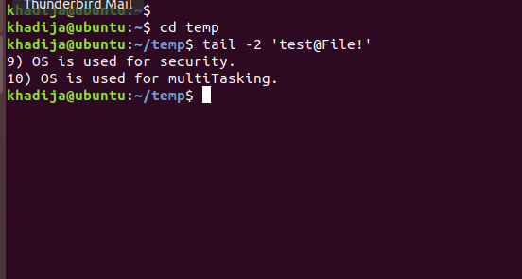

Q7)

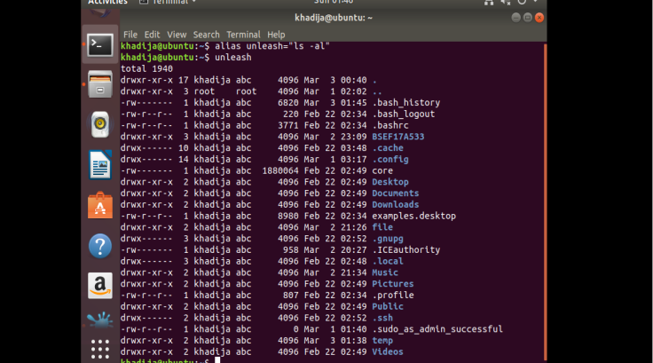

Q8)

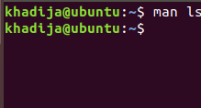

Q9)

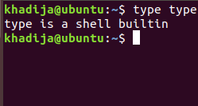

Q10)

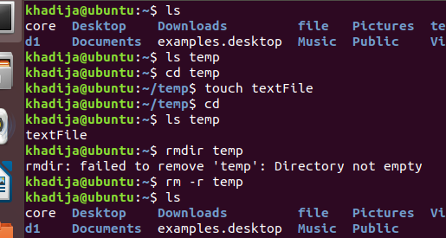

RELATIVE/ABSOLUTE PATH

Q1)



Q2)

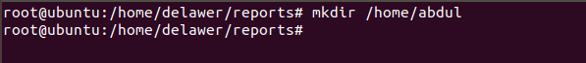

Q3)

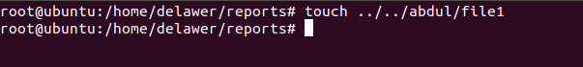

Q4)

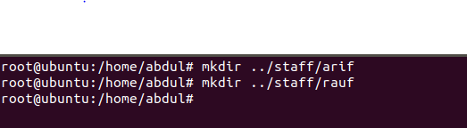

Q5)

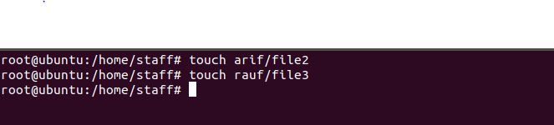

Q6)

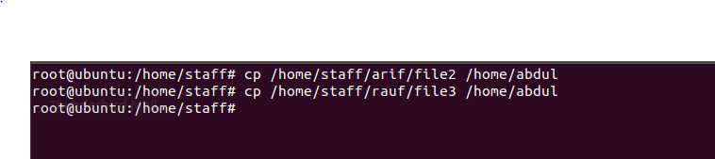

Q7)

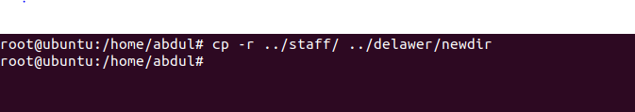

Q8)

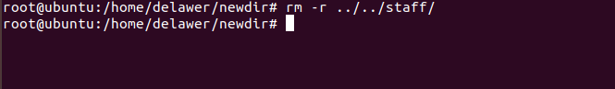

Q9)

